Object Biography Assignments

The Academic Engagement Department at the Penn Museum is committed to fostering student research on collections and we encourage faculty to explore an Object-Based Learning (OBL) approach in their courses.

Object Biography assignments are a well-established method for incorporating OBL into curriculum and can be adapted to fit course needs. In the assignment, students select an object to research and describe in depth. Such projects challenge students to use objects as evidence to further explore and understand their course content from a cultural perspective.

Why a ‘biography’? An object biography is a theoretical perspective and methodological tool to elucidate the relationship between people and objects, and was perhaps most famously championed by University of Pennsylvania anthropologist Igor Kopytoff (1986). By examining the circumstances along an object’s “lifecycle”, both the unique qualities of the individual object and the insight it can give into larger social contexts are unveiled. This methodology requires the consideration of the agency of objects and their makers, and conflicting views about the value and circulation of objects as they move through various social contexts.

To discuss incorporating an Object Biography assignment into a course, please contact our Curricular Facilitator Anne Tiballi at atiballi@upenn.edu.

Project Recommendations
- Students study an object on display in the public galleries. This is ideal for instances in which the course content closely aligns with the material on display. This type of project also allows for more flexibility, as students are welcome to visit the galleries to view an object during public hours.
- Students make an appointment to study an object from storage. In order to provide clear project parameters for students, we recommend that faculty work with the Academic Engagement Department to create a pre-approved list of about 10-15 objects from which students can choose, depending on class size and project objectives. Refer to our online collections database for object information. Please submit the object list at least 3 weeks prior to the start of student research visits to classuse@pennmuseum.org.
Once an object list has been approved, students should fill out the student research request form to set up individual appointment times for the Collections Study Room. Student research appointments should be made at least one week in advance.

Other Resources

In many instances, further exploration of the object’s contextual history may greatly contribute to our understanding of its significance. The following resources are available to students who wish to do a more in depth object investigation:
- To access object records or accession files, students must make an appointment (in advance) with the Registrar for Records by e-mailing objectrecords@pennmuseum.org.
- To view field records or other archival material, students must make an appointment (in advance) with the Museum Archives by contacting archives@pennmuseum.org.

Due to the long history of collecting and excavation at the Penn Museum, as well as respect for the privacy of our recent donors, some information contained in object records may be incomplete or confidential.

Object Biography Instructions

The biography of an object should not be restricted to an historical reconstruction of its birth, life and death. Biography is relational and an object biography is comprised of the sum of the relationships that constitute it. [Joy, 2009: 552]
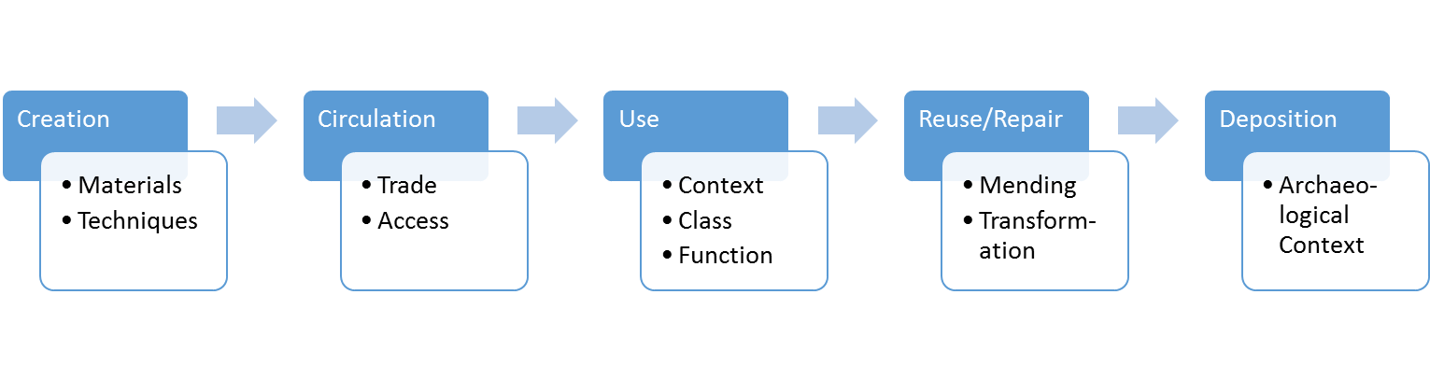
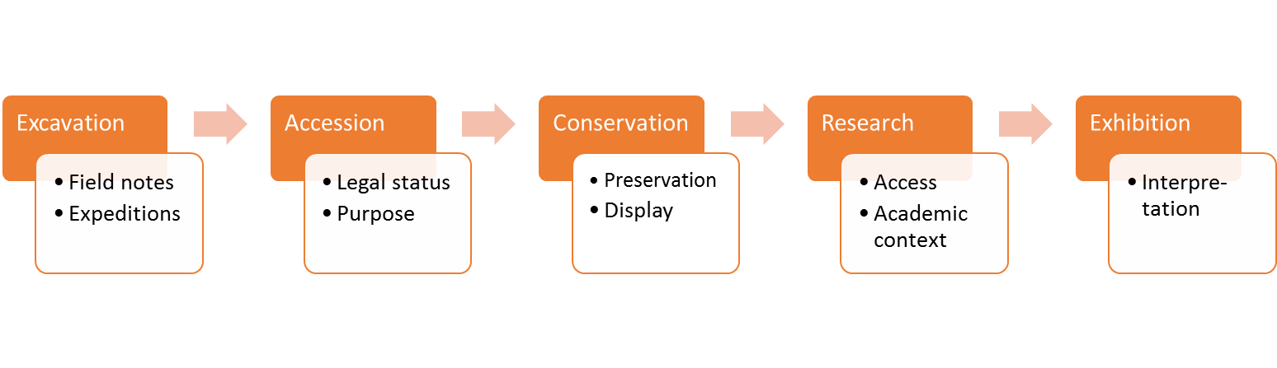

References
Joy, Jody 2009. “Reinvigorating Object Biography: Reproducing the Drama of object Lives”, World Archaeology, 41(4): 540-556.

Kopytoff, Igor 1986. ‘The Cultural Biography of Things: Commoditization as a Process’, in Arjun Appadurai (ed.) The Social Life of Things: Commodities in Social Perspective, pp. 64-94. Cambridge: Cambridge University Press.

