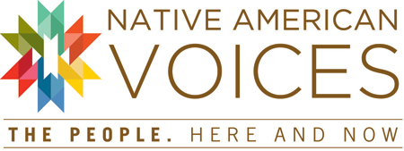

Opening Celebration and Related Programs

An Opening Day Celebration Saturday March 1, and related events in March and April, kick off the new exhibition Native American Voices: The People—Here and Now. A website, launching February 1, 2014, invites visitors to delve deeper: www.penn.museum/NAV.

Saturday, March 1, 11:00 am - 4:00 pm
Exhibition Opening Celebration
Native American Voices: The People—Here and Now
Native Americans from around the region and across North America come to the Penn Museum Saturday, March 1, 11:00 am to 4:00 pm, to share their art, culture, and perspectives and to celebrate the opening of Native American Voices: The People—Here and Now. Native Nations Dance Theater, a local group which performs internationally, offers workshops and performances in an afternoon which features storytelling, talks and demonstrations by Native American leaders in film and journalism, scholarship, community development, archaeology, language retention and social activism. Mini-workshops, special activities for families, and Native American foods on the Pepper Mill Café menu, round out the day. Free with Museum admission. Details online.

Saturday, March 1 though Sunday, March 9
Philadelphia Flower Show
Featuring: Landscape Garden Inspired by Native American Voices Exhibition
ARTiculture—where art meets horticulture—is this year’s Philadelphia Flower Show theme, and the Penn Museum is honored to be collaborating with award-winning Hunter Haye’s Landscape Design of Ardmore, Pennsylvania, on a landscape garden inspired by Native American Voices: The People—Here and Now. The garden exhibition space, one of more than a dozen displays inspired by major local, national and international museums, depicts a contemporary back yard garden, combining clean lines and minimalistic design with colors, textures, shapes, and patterns derived from various Native American cultures and regions. The multi-level garden offers simple, repetitive plantings and unique accents to create a space both stimulating and relaxing. Special offer: during the month of March, Penn Museum visitors who show their Flower Show ticket or ticket stub receive $3 off general Museum admission donation. Flower Show details: www.theflowershow.com

Sunday, March 9, 1:00 - 4:00 pm
Second Sunday Family Workshop
Southwest Ceramics
Children and their families can learn about the abstract designs, which allude to relationships between people and their environment, found on pottery from the Hopi, and Zuni Pueblo peoples of the Southwest. Everyone can illustrate 2-D pottery shapes inspired by the designs of the Southwest, and explore the newly installed exhibition, Native American Voices: The People—Here and Now, with a scavenger hunt. Walk-in workshop. Free with Museum admission.

Saturday, March 22, 10:30 - 11:15 am
Young Family Event
Gallery Romp: Native America
Young children (ages 3–6) and their favorite grownups are invited to explore the Penn Museum's galleries through stories, crafts, and play. Bundle up and go on a fishing trip to the Arctic with Kumak and his family. How many fish will you catch? Each workshop is limited to 25 people and advance registration before the program date is encouraged. Programs are free with Museum admission. Visit www.penn.museum/romps to register. If you are a Museum Member at the Household level or higher or a PennCard holder, please call 215.898.4016 to complete your registration.

Wednesday, April 16, 6:00 pm
Annual Elizabeth Watts and Howard C. Petersen Lecture
Lacrosse: Play on, Iroquois Nationals!
Oren Lyons, Jr., world renowned Native American peace activist, Honorary Chairman of the Iroquois Nationals Lacrosse Team, and Faithkeeper of the Turtle Clan of the Seneca Nation of the Iroquois Confederacy, speaks about the spiritual origins of lacrosse, and his international peacekeeping and environmental efforts around the globe. Lecture admission: Pay-what-you-want.

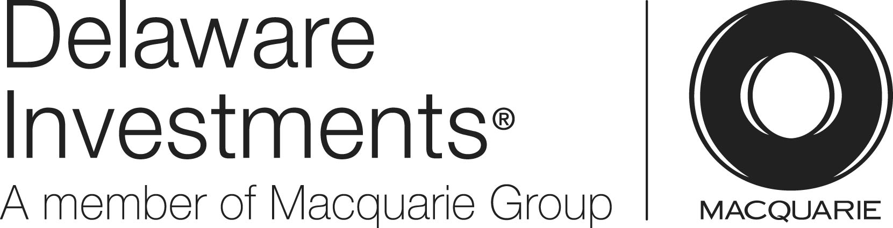
Native American Voices public programming is generously underwritten by Delaware Investments/Macquarie Group Foundation.

The Penn Museum (the University of Pennsylvania Museum of Archaeology and Anthropology) is dedicated to the study and understanding of human history and diversity. Founded in 1887, the Museum has sent more than 300 archaeological and anthropological expeditions to all the inhabited continents of the world. With an active exhibition schedule and educational programming for children and adults, the Museum offers the public an opportunity to share in the ongoing discovery of humankind's collective heritage.

The Penn Museum is located at 3260 South Street, Philadelphia, PA 19104 (on Penn's campus, across from Franklin Field). Public transportation to the Museum is available via SEPTA's Regional Rail Line at University City Station; the Market-Frankford Subway Line at 34th Street Station; trolley routes 11, 13, 34, and 36; and bus routes 21, 30, 40, and 42. Museum hours are Tuesday and Thursday through Sunday, 10:00 am to 5:00 pm, and Wednesday, 10:00 am to 8:00 pm, with P.M. @ PENN MUSEUM evening programs offered select Wednesdays. Closed Mondays and holidays. Admission donation is $15 for adults; $13 for senior citizens (65 and above); $10 for children and full-time students with ID; free to Members, active U.S. Military, PennCard holders, and children 5 and younger.

Hot and cold meals and light refreshments are offered to visitors with or without Museum admission in The Pepper Mill Café; the Museum Shop and Pyramid Shop for Children offer a wide selection of gifts, books, games, clothing and jewelry. Penn Museum can be found on the web at www.penn.museum. For general information call 215.898.4000. For group tour information call 215.746.8183.

