Native American Voices: The People—Here and Now
Native Americans from around the Country Join the
Opening Celebration at the Penn Museum Saturday, March 1

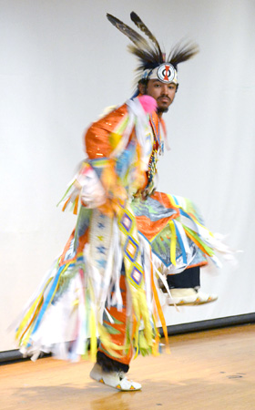
Native Americans from around the region and across North America come to the Penn Museum Saturday, March 1, 11:00 am to 4:00 pm, to share their art, culture, and perspectives and to celebrate the opening of Native American Voices: The People—Here and Now. Native Nations Dance Theater performs in an afternoon that features talks, demonstrations and storytelling by Native American leaders in film and journalism, scholarship, community development, archaeology, sports, language retention and social activism. Mini-workshops, special activities for families, and Native American foods on the Pepper Mill Café menu, round out the day.

Penn Museum Williams Director Julian Siggers joins Exhibition Curator and Senior Keeper of the American Section Lucy Fowler Williams, Keeper of the American Section William Wierzbowski, and advisors and consultants from the Native American community, at an 11:00 am ribbon cutting ceremony to officially open the new exhibition.

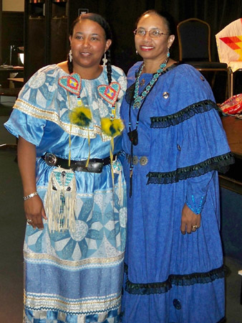
Native Nations Dance Theater offers a dance demonstration and open workshop at 11:30 am, and a music workshop and demonstrations at 1:00 pm. The performers return at 3:30 pm for a finale performance. The group is under the direction of Founder and Director Vaughnda Hilton, who is from the Blackfeet, Seminole and Creek nations. Developed to educate people about the presence of Native American artists and cultures in their communities, Native Nations Dance Theater has offices in Philadelphia and Washington D.C. The group has performed internationally at more than 500 schools, visiting Abu Dhabi, Central Asia, Canada, the Eastern Caribbean, England, and Greece.

Namorah Gayle Byrd, Chitimacha/Cherokee, an Associate Professor of Composition and Literature at Gloucester County College and a member of the Native Nations Dance Theater, tells Native American trickster tales during storytelling times at 12:30 and 2:30 pm.
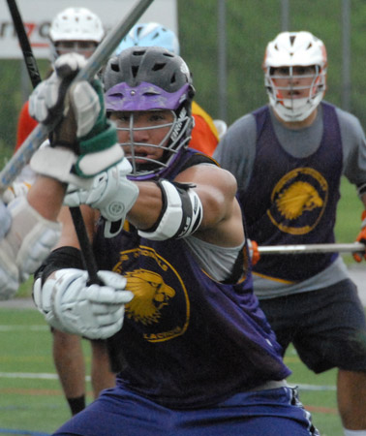
Now popular around the world, the game of lacrosse originated among Native American communities. At 1:00 pm and again at 2:45 pm, Gewas Schindler, the General Manager of the Iroquois Nationals Lacrosse Team (Haudenosaunee/Oneida), joins the celebration, for a demonstration and talk about the history and significance of the game. Haudenosaunee legend states that Lacrosse is a reminder of the talents hidden within all people. Penn Museum houses a collection of Iroquois lacrosse sticks, several of which are on display in the new exhibition.

More than 80 Native American consultants have contributed to the exhibition, and several specialists offer their knowledge and perspectives. At 12:00 noon, Suzan Harjo, Cheyenne/Muskogee, Director of the Morningstar Institute and a lead advisor for the exhibition, offers a reading of her own poetry about sacred places, with time to talk and answer questions about the importance of places on the landscape for Native American peoples today. From 1:30 pm, Joe Watkins, Choctaw, National Park Service Chief Archaeologist, shares insights into indigenous archaeology, while Joseph Aguilar, Tewa Pueblo, and a University of Pennsylvania graduate student, talks about his archaeological research to understand how his ancestors experienced the Pueblo Revolt of 1680.

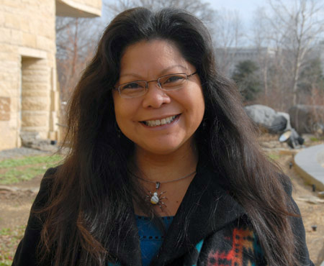
Shelley DePaul, Chief, Lenape Nation of Pennsylvania, introduces visitors to the local Lenape Indian language at a workshop at 2:00 pm. Margaret Bruchac, Abenaki, Assistant Professor of Anthropology, speaks about the role of wampum, drawing upon materials from the Penn Museum collection, at 2:30 pm. Advisor Patty Talahongva, a Hopi journalist and filmmaker whose work formed the basis of much of the video content in the exhibition, speaks about her work as a journalist and shares aspects of her Hopi culture, drawing on material inspirations in the Penn Museum collection, at 3:00 pm.
Throughout the afternoon, members of Natives @ Penn, the University of Pennsylvania's Native American student group, host a hands-on craft activity for all ages.

Beginning at 2:00 pm, guests may sign up for a behind-the-scenes visit to the Museum’s Collections Study Room, where Collections Assistant Stephanie Mach, Diné, offers an up-close look at some diverse Native American materials from the vast North American collections, which number over 140,000.

A special issue of Expedition, the Penn Museum’s membership magazine, explores Native American sovereignty through the work of Native American leaders of many walks of life. Visitors who join the Museum receive a complimentary copy of the issue, featuring articles that delve deeper into some of the exhibition themes and issues.

TWEET IT: Join Native American leaders from across the country to open @pennmuseum’s “Native American Voices” exhibition, 3/1: http://bit.ly/1mRTiEI

The Penn Museum (the University of Pennsylvania Museum of Archaeology and Anthropology) is dedicated to the study and understanding of human history and diversity. Founded in 1887, the Museum has sent more than 300 archaeological and anthropological expeditions to all the inhabited continents of the world. With an active exhibition schedule and educational programming for children and adults, the Museum offers the public an opportunity to share in the ongoing discovery of humankind's collective heritage.

The Penn Museum is located at 3260 South Street, Philadelphia, PA 19104 (on Penn's campus, across from Franklin Field). Public transportation to the Museum is available via SEPTA's Regional Rail Line at University City Station; the Market-Frankford Subway Line at 34th Street Station; trolley routes 11, 13, 34, and 36; and bus routes 21, 30, 40, and 42. Museum hours are Tuesday and Thursday through Sunday, 10:00 am to 5:00 pm, and Wednesday, 10:00 am to 8:00 pm, with P.M. @ PENN MUSEUM evening programs offered select Wednesdays. Closed Mondays and holidays. Admission donation is $15 for adults; $13 for senior citizens (65 and above); $10 for children and full-time students with ID; free to Members, active U.S. Military, PennCard holders, and children 5 and younger.

Hot and cold meals and light refreshments are offered to visitors with or without Museum admission in The Pepper Mill Café; the Museum Shop and Pyramid Shop for Children offer a wide selection of gifts, books, games, clothing and jewelry. Penn Museum can be found on the web at www.penn.museum. For general information call 215.898.4000. For group tour information call 215.746.8183.

Click here to access hi-res images and captions.

Image captions (from top): Performers from Native Nations Dance Theater, including Andew Lyn (pictured), the group's Assistant Director, present dance demonstrations and workshops during the opening celebration of Native American Voices: The People—Here and Now (photo: Penn Museum); Native Nations Dance Theater Director Vaughnda Hilton poses with storyteller Namorah Byrd, who shares traditional tales during the opening celebration of Native American Voices: The People—Here and Now (photo courtesy of Native Nations Dance Theater); Performers from Native Nations Dance Theater, including Director Vaughnda Hilton (left) and singer/storyteller Namorah Gayle Bird (right), present traditional dance, music, and storytelling during the opening celebration of Native American Voices: The People—Here and Now (photo courtesy of Native Nations Dance Theater); a member of the Iroquois National Lacrosse Team joins the opening celebration of Native American Voices: The People—Here and Now for a demonstration and talk about the history and significance of the game (photo: Lucy Fowler Williams); Exhibition Advisor Patty Talahongva, a Hopi journalist and filmmaker whose work formed the basis of much of the video content in the exhibition, speaks about her work as a journalist and shares aspects of her Hopi culture during the opening celebration of Native American Voices: The People—Here and Now (photo: Lucy Fowler Williams).

