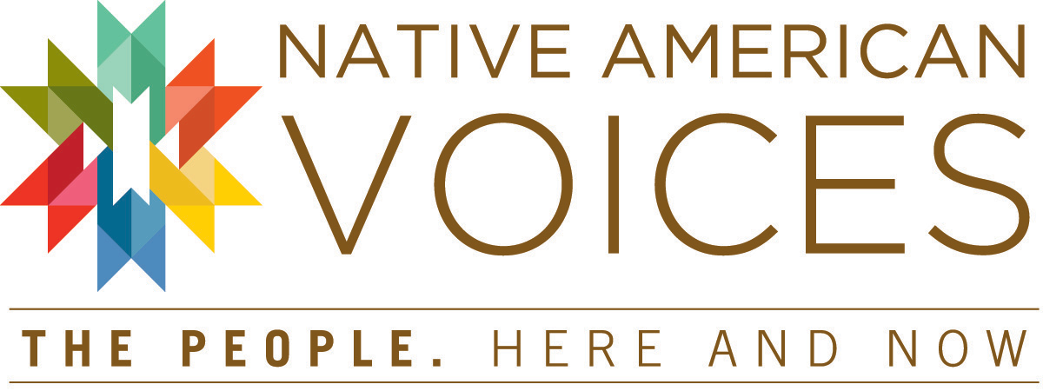
Related Materials
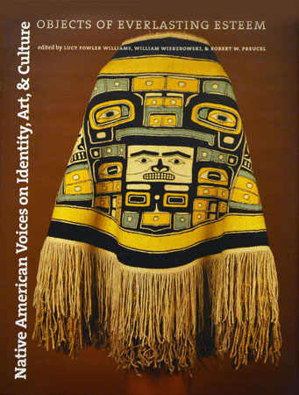
Native American Voices on Identity, Art, & Culture: Objects of Everlasting Esteem (2005)
Edited by Lucy Fowler Williams, William Wierzbowski, and Robert W. Preucel
The dynamic discourse stimulated by 78 magnificent objects created by Native Americans over the years and now housed in the Penn Museum, and the responses of contemporary Native Americans to those objects—responses in stories, poems, essays—form the core of this richly illustrated, full-color hardback book. The book itself helps define the Museum’s role within the realms of a large research university and the general public, presenting and clarifying some of the connections between the Museum and Native American communities. Penn Museum Shop, $49.95.
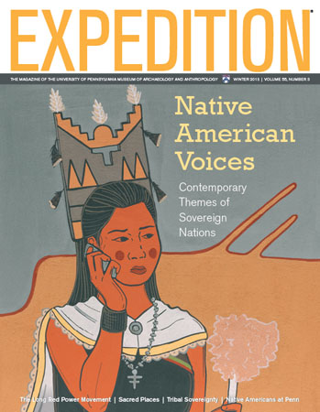
Expedition magazine, Winter 2013/2014
This special issue of the Penn Museum’s Expedition magazine is an extension of the Museum’s new exhibition, Native American Voices: The People—Here and Now. Native American sovereignty is explored through the work of Native American leaders of many walks of life, several of whom served as content advisors to the exhibition—including Suzan Shown-Harjo (Cheyenne & Hodulgee Muscogee), Tina Pierce Fragoso (Nanticoke Lenni-Lenape),and Patty Talahongva (Hopi).
Special offer while supplies last! Expedition magazine is the official members' magazine of the Penn Museum. Guests who join the Penn Museum when visiting the exhibition receive a complimentary copy of this special issue at the admissions desk!

